**ACHUT MANYANG MAGER SCT221-C004-0533/2022**

**DANIEL GARANG ALEU SCT221-COO4-0034/2023**

**DARRYLL KAMAU SCT221-C004-0129/2023**

**1) Railway Reservation System Prototype**

The railway reservation system functions as follows;

The passenger is required to fill in a reservation form giving detail of his journey. The counter clerk ensures whether the place is available. If so, entries are made in a register, tickets are prepared, amount is computed and cash is accepted.

A booking statement is prepared in triplicate format from the reservation register. One copy is retained as office copy, the other is pasted to the compartment and third is passed on to the train conductor. Besides booking statement, cash statement is prepared at the end of each shift.

Prepare System Require Specification and system specification for above system problem.

Design a prototype for the case study

Certainly! Here's a simplified System Requirements Specification (SRS) and System Specification for the described railway reservation system:

**System Requirements Specification (SRS):**

1. **Introduction:**

The railway reservation system allows passengers to book train tickets by filling out a reservation form.

The system should be capable of handling multiple reservations concurrently.

It must provide real-time availability information.

It should generate booking statements and cash statements.

2**. Functional Requirements:**

**Reservation Form:**

The system should provide a user-friendly reservation form to capture passenger journey details.

**Availability Check:**

The system must check the availability of seats or berths for the selected journey.

**Reservation Entry:**

If seats are available, the system should record passenger details in a reservation register.

**Ticket Preparation:**

The system should generate train tickets with relevant passenger information.

**Amount Calculation:**

It should calculate the total ticket cost based on journey details.

**Payment Processing:**

The system should accept cash from the passenger for the booking.

**Booking Statement:**

Prepare a booking statement in triplicate format with passenger details.

**Cash Statement:**

Prepare a cash statement at the end of each shift to account for all transactions.

3. **Non-Functional Requirements:**

**Security:**

Ensure data security and privacy of passenger information.

**Performance:**

The system should handle a large number of transactions without significant delays.

**Reliability:**

The system must be available 24/7 with minimal downtime.

**User Interface:**

The reservation form should be intuitive and easy to use.

4. **System Specification:**

4.1 **Hardware Requirements:**

Server for the reservation system.

Computers at ticket counters.

Printers for ticket generation.

Cash handling equipment.

4.**2 Software Requirements:**

Reservation management software.

Database system to store passenger and availability data.

User interface for passengers and counter clerks.

Reporting tools for statement generation.

**4.3 Data Flow:**

Passenger fills the reservation form.

Clerk checks seat availability.

If available, data is recorded, and tickets are generated.

Cash is accepted.

Booking and cash statements are prepared.

**4.4 Security:**

Use encryption for sensitive data.

Access control for system components.

Regular data backups.

**4.5 User Interfaces:**

Passenger reservation form.

Counter clerk interface for seat availability and booking.

Reporting interface for statement generation.

**Design a Prototype:**

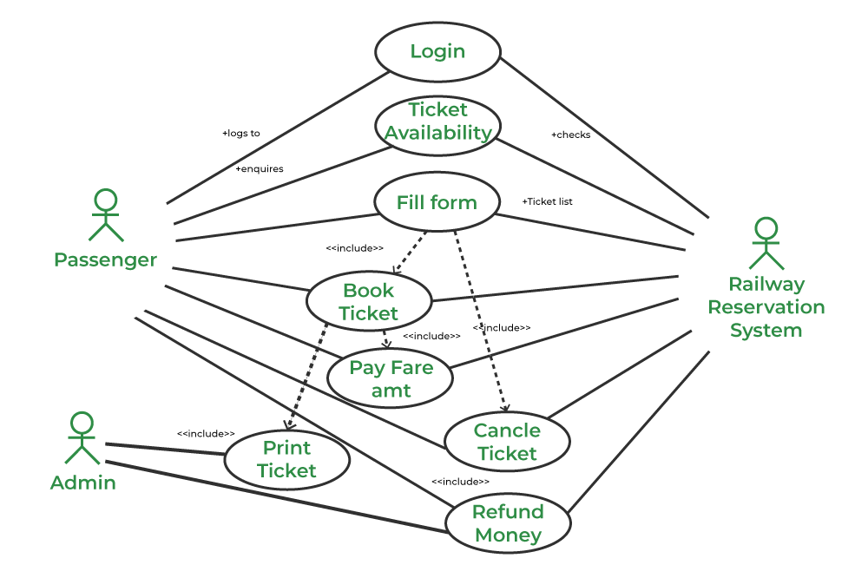

**2) Discuss the following software testing techniques (walkthroughs, reviews and inspections, dynamic testing, Traceability matrices. Debugging environments)**

Computer-Aided Software Engineering (CASE) tools are software applications that assist in the development and maintenance of information systems. In the context of Web engineering techniques and processes, as well as standards and guidelines, CASE tools play a significant role in enhancing productivity, collaboration, and adherence to industry best practices. Here's how CASE tools are utilized in the field of Web engineering:

**1. Design and Modeling:**

Usage: CASE tools facilitate the creation of visual models for websites, including data models, process models, and user interface designs.

Benefits: Designers can create wireframes and prototypes, enabling stakeholders to visualize the website layout and functionality before development. This ensures that the design adheres to standards and guidelines.

**2. Requirements Management:**

Usage: CASE tools help in gathering, documenting, and managing requirements for the web project.

Benefits: By organizing requirements systematically, development teams can ensure that the web application meets user needs and complies with industry standards. Changes and updates can be tracked efficiently.

**3. Code Generation and Implementation:**

Usage: Some advanced CASE tools can automatically generate code snippets or even entire modules based on the design and modeling done within the tool.

Benefits: This feature accelerates the development process, reduces the likelihood of coding errors, and promotes adherence to coding standards and guidelines.

**4. Collaboration and Communication:**

Usage: CASE tools often provide collaboration features, allowing team members to work together on the same project, share documents, and communicate within the tool.

Benefits: Enhanced collaboration ensures that all team members are on the same page regarding project requirements, design decisions, and coding standards. It fosters better communication and coordination among team members.

**5. Version Control and Change Management:**

Usage: Many CASE tools integrate with version control systems, enabling teams to manage changes, track revisions, and maintain a history of modifications.

Benefits: Version control ensures that the web project follows a systematic approach to changes and updates. It helps in maintaining the integrity of the codebase, ensuring compliance with standards, and allowing easy rollback in case of issues.

**6. Compliance with Standards and Guidelines:**

Usage: CASE tools can be configured to check code against industry standards and coding guidelines.

Benefits: Automated code analysis ensures that the web application adheres to best practices, security standards, and coding conventions. It helps in identifying and rectifying issues related to standards compliance.

**3) Discuss Software Quality Evaluation – Problems, Software standards, Certification, Software Tools support for Systems Engineering**

Software Quality Evaluation: Problems and Solutions:

**1. Problems in Software Quality Evaluation:**

**Subjectivity:** Evaluating software quality can be subjective, varying from person to person.

**Changing Requirements**: Shifting project requirements can lead to difficulties in defining quality criteria.

**Complexity:** Modern software systems are complex, making it challenging to assess all aspects thoroughly.

**Lack of Metrics:** Absence of standardized metrics for quality evaluation poses a challenge.

**Budget and Time Constraints:** Limited resources can hinder comprehensive quality evaluations.

**2. Solutions:**

**Standardized Metrics:** Define clear, standardized metrics for evaluating software quality, covering aspects like performance, reliability, security, and maintainability.

**4) Discuss the following software testing techniques (walkthroughs, reviews and inspections, dynamic testing, Traceability matrices. Debugging environments)**

**1. Walkthroughs:**

**Definition:** Walkthroughs are informal, yet structured, peer reviews of software code or documentation. During a walkthrough, the author explains their work to colleagues, seeking feedback and identifying issues.

**Purpose:** Walkthroughs help in identifying defects early in the development process, encourage knowledge sharing among team members, and ensure that code or documentation adheres to the required standards.

**2. Reviews and Inspections:**

**Definition:** Reviews and inspections are formal methods of examining software work products. They involve a systematic and detailed examination of the software artifacts to find defects, ensure compliance with standards, and improve overall quality.

**Purpose:** Reviews and inspections provide a systematic approach to finding defects and improving the quality of software products. They are typically more structured than walkthroughs and involve specific roles such as moderator, author, and reviewers.

**3. Dynamic Testing:**

**Definition:** Dynamic testing involves the execution of the software code to identify defects or errors. It includes various testing types like unit testing, integration testing, system testing, and acceptance testing.

**Purpose:** Dynamic testing validates the behavior of the software under specific conditions. It helps in identifying functional and non-functional issues, ensuring the software functions as intended, and meets the specified requirements.

**4. Traceability Matrices:**

**Definition:** Traceability matrices are documents that establish a traceable link between requirements, design, and test cases. They ensure that every requirement has associated test cases and that all requirements are tested.

**Purpose:** Traceability matrices help in tracking the progress of testing concerning requirements coverage. They ensure that all requirements are addressed, and any changes in requirements can be easily traced to the impacted test cases, aiding in comprehensive test coverage.

5. Debugging Environments:

**Definition:** Debugging environments provide tools and features for developers to identify, analyze, and fix defects in the software code. Debuggers allow step-by-step execution of code, inspection of variables, and setting breakpoints.

**Purpose:** Debugging environments are crucial for developers to identify and fix defects during the development phase. They help in understanding the code flow, locating errors, and verifying code behavior, leading to the production of high-quality software.

**5) Discuss Process Improvement (PI):- Quality and process standards and guidelines**

Process Improvement (PI) involves identifying, analyzing, and improving existing processes within an organization to enhance efficiency, quality, and overall performance. Quality and process standards and guidelines play a crucial role in PI efforts. Here's how:

**1. Establishing Quality Standards:**

**Definition**: Quality standards define the criteria that a product, service, or process must meet to be considered acceptable or of high quality.

**Role in PI:** By setting clear quality standards, organizations can measure their current processes against these benchmarks. Deviations from the standards indicate areas that need improvement, guiding PI initiatives.

**2. Adhering to Process Standards:**

**Definition:** Process standards are established procedures and guidelines that dictate how tasks and activities should be performed within an organization.

**Role in PI:** Standardizing processes ensures consistency and helps in identifying inefficiencies or deviations from the established norms. PI initiatives often involve evaluating processes against these standards to identify areas for enhancement.

**3. Implementing Best Practices:**

**Definition:** Best practices are proven techniques or methods that have consistently shown superior results.

**Role in PI:** Organizations adopt best practices as guidelines for their processes. Continuous assessment and integration of these practices into existing processes lead to improved efficiency, reduced errors, and enhanced quality.

**4. Compliance with Industry Regulations:**

**Definition:** Industry-specific regulations and standards ensure that organizations comply with legal requirements and industry norms.

**Role in PI:** Ensuring compliance with regulations is critical. PI efforts focus on aligning processes with these standards to prevent legal issues, reduce risks, and maintain high-quality outputs.

**5. Continuous Monitoring and Feedback:**

**Definition:** Regularly evaluating processes and collecting feedback from stakeholders to identify areas for improvement.

**Role in PI:** Continuous monitoring against quality and process standards helps in detecting deviations promptly. Feedback from employees and customers provides valuable insights, guiding PI initiatives and ensuring sustained process improvement.

**6. Training and Skill Development:**

**Definition:** Providing training programs and skill development opportunities to employees to enhance their expertise.

**Role in PI:** Properly trained employees are more likely to adhere to quality and process standards. Training programs equip staff with the knowledge and skills needed to meet the established standards, contributing to overall process improvement.